**How to add a pricing variation in Exerp**

1. Go to the member’s profile and select the Membership tab
2. Select the subscription you wish to update

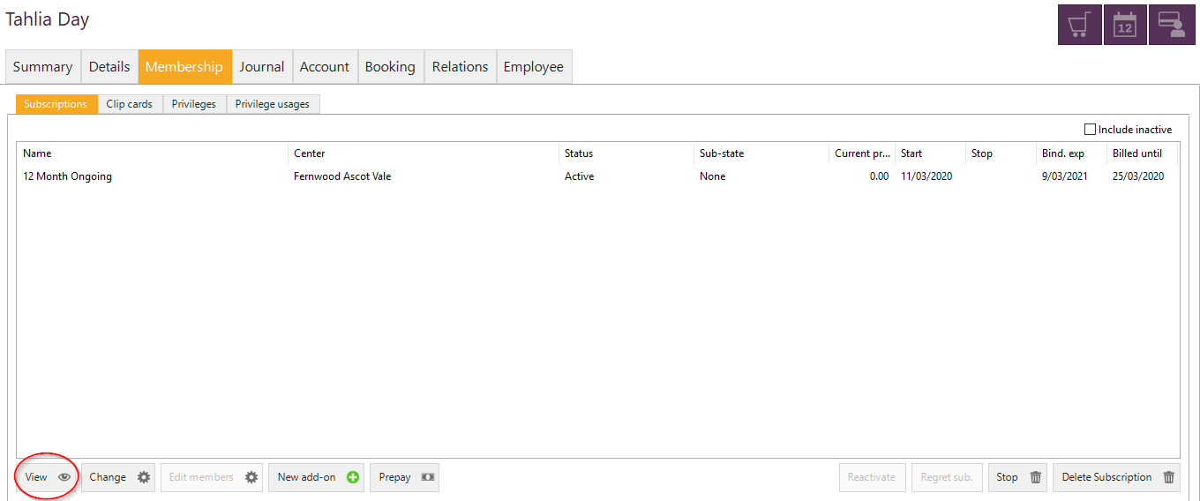

1. 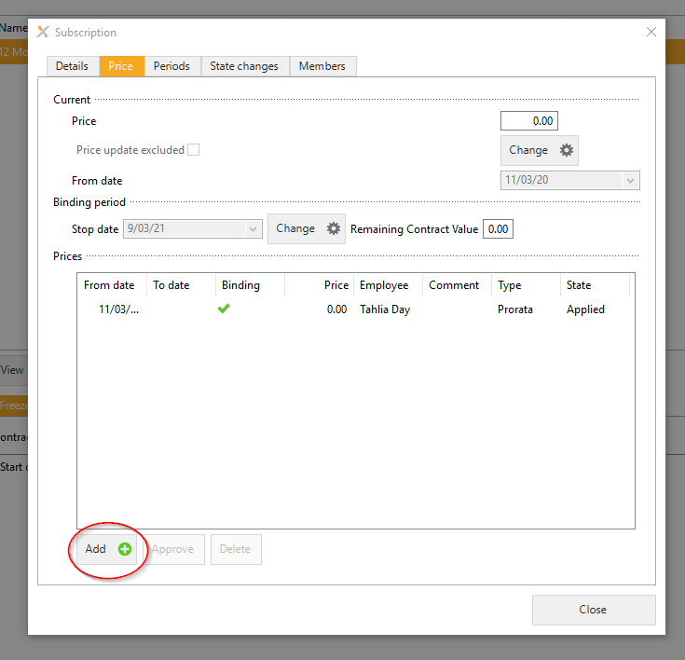In the subscription window that pops up > go to the Price tab > Select Add
2. Adjust the price text box to what is applicable to the member, check the change date and make a comment i.e. COVID-19 Adjustment

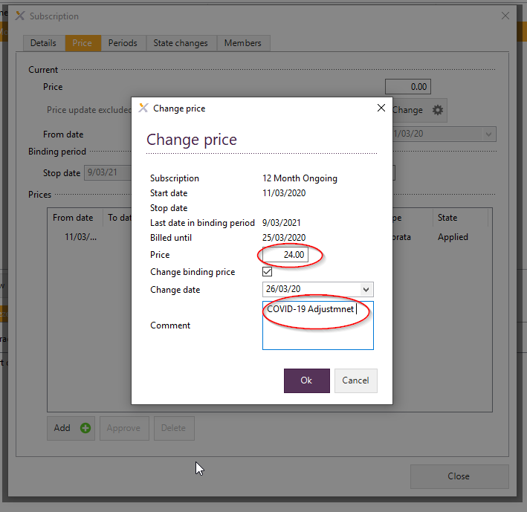

1. Click OK and Close to complete the Price update.